6/12/2020

Nabiya Fatima BSE173011 Iqra Ishtiaq BSE173043

Software Testing

Assignment 4

Contents

**Case Study** 2

**Flow Chart** 2

**Modified Condition Decision Coverage** 3

**Path Predicate Expressions** 4

**Test Oracle** 5

# 

# **Case Study**

In a programming competition the students are required to design a program that takes three numbers (a, b, c) as inputs and determine whether the equation is Quadratic or not. The standard form of Quadratic Equation is ax2+bx+c=0, where a, b, c are constants and “a” cannot be zero. The program should have a method that calculates the nature of the roots of the Quadratic equation weather the roots of the equation are Real, Equal or Imaginary using the discriminant b2-4ac. Following are the conditions that should be meet:

• If b2-4ac>0 the roots are Real and Unequal.

• If b2-4ac=0 the roots are Real and Equal.

• If b2-4ac<0 the roots are Imaginary.

The program also depicts the shape of parabola i.e. (the shape of parabola is upwards or downwards depending on the value of a).

# **Flow Chart**

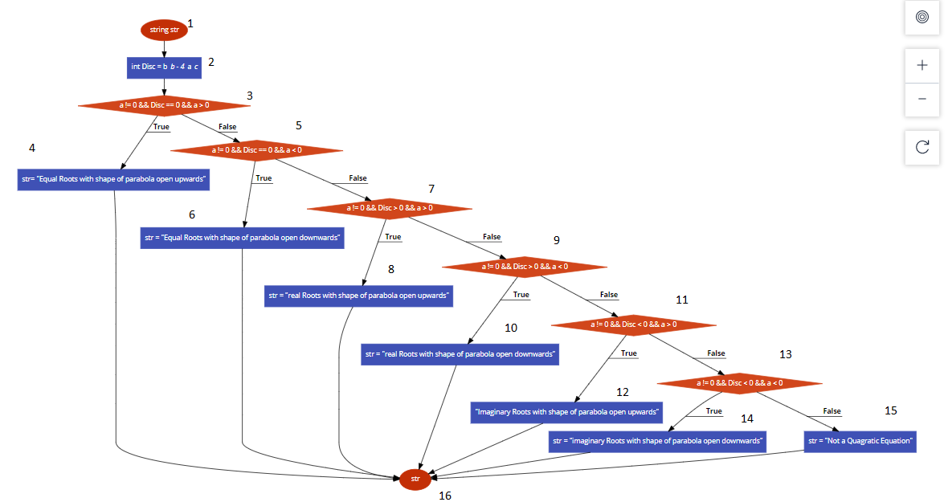

# **Modified Condition / Decision Coverage**

|  |  |  |  |  |
| --- | --- | --- | --- | --- |
| **Sr.No** | **a** | **b** | **c** | **a != 0 && Disc == 0 && a >= 1** |
| 1 | F | F | F | F |
| 2 | F | F | T | F |
| 3 | F | T | F | F |
| 4 | F | T | T | F |
| 5 | T | F | F | F |
| 6 | T | F | T | F |
| 7 | T | T | F | F |
| 8 | T | T | T | T |

|  |  |  |  |  |
| --- | --- | --- | --- | --- |
| **Sr.No** | **a** | **b** | **c** | **a != 0 && Disc == 0 && a <= -1** |
| 1 | F | F | F | F |
| 2 | F | F | T | F |
| 3 | F | T | F | F |
| 4 | F | T | T | F |
| 5 | T | F | F | F |
| 6 | T | F | T | F |
| 7 | T | T | F | F |
| 8 | T | T | T | T |

|  |  |  |  |  |
| --- | --- | --- | --- | --- |
| **Sr.No** | **a** | **b** | **c** | **a != 0 && Disc > 0 && a >= 1** |
| 1 | F | F | F | F |
| 2 | F | F | T | F |
| 3 | F | T | F | F |
| 4 | F | T | T | F |
| 5 | T | F | F | F |
| 6 | T | F | T | F |
| 7 | T | T | F | F |
| 8 | T | T | T | T |

|  |  |  |  |  |
| --- | --- | --- | --- | --- |
| **Sr.No** | **a** | **b** | **c** | **a != 0 && Disc > 0 && a <= -1** |
| 1 | F | F | F | F |
| 2 | F | F | T | F |
| 3 | F | T | F | F |
| 4 | F | T | T | F |
| 5 | T | F | F | F |
| 6 | T | F | T | F |
| 7 | T | T | F | F |
| 8 | T | T | T | T |
| **Sr.No** | **a** | **b** | **c** | **a != 0 && Disc < 0 && a <= 1** |
| 1 | F | F | F | F |
| 2 | F | F | T | F |
| 3 | F | T | F | F |
| 4 | F | T | T | F |
| 5 | T | F | F | F |
| 6 | T | F | T | F |
| 7 | T | T | F | F |
| 8 | T | T | T | T |

|  |  |  |  |  |
| --- | --- | --- | --- | --- |
| **Sr.No** | **a** | **b** | **c** | **a != 0 && Disc < 0 && a <= -1** |
| 1 | F | F | F | F |
| 2 | F | F | T | F |
| 3 | F | T | F | F |
| 4 | F | T | T | F |
| 5 | T | F | F | F |
| 6 | T | F | T | F |
| 7 | T | T | F | F |
| 8 | T | T | T | T |

# **Note**

The highlighted test cases 4,6,7,8 are sufficient for MD/DC and the test cases 1,2,3,5 are redundant.

# **Path Predicate Expressions**

|  |  |  |
| --- | --- | --- |
| **SR.NO** | **Path Predicate Expression** | **Path** |
| 1. | a!=0 && Disc==0&&a>=1 | 1-> 2->3->4->16 |
| 2. | a!=0 && Disc==0&&a<=-1 | 1-> 2-> 3->5->6->16 |
| 3. | a!=0 && Disc>0&&a>=1 | 1->2->3->3->7->8->16 |
| 4. | a!=0 && Disc>0&&a<=-1 | 1->2->3->5->7->9->10->16 |
| 5. | a!=0 && Disc<0&&a>=1 | 1->2->3->5->7->9->11->12  ->16 |
| 6. | a!=0 && Disc<0&&a<=-1 | 1->2->3->5->7->9->11->13  ->14->16 |
| 7. | a==0 | 1->2->3->5->7->9->11->13  ->15->16 |

# **Test Oracle**

|  |  |  |  |  |  |  |
| --- | --- | --- | --- | --- | --- | --- |
| **Sr.No** | **Inputs** | | | **Path** | **Actual Output** | **Expected Output** |
| **a** | **b** | **c** |
| 1 | 1 | 0 | 0 | 1-> 2->3->4->16 | Equal Roots with shape of parabola open upwards. | Equal Roots with shape of parabola open upwards. |
| 2 | -1 | 0 | 0 | 1-> 2-> 3->5->  6->16 | Equal Roots with shape of parabola open downwards. | Equal Roots with shape of parabola open downwards. |
| 3 | 1 | 1 | 0 | 1->2->3->3->7->8->16 | Real Roots with shape of parabola open upwards**.** | Real Roots with shape of parabola open upwards**.** |
| 4 | -1 | 1 | 0 | 1->2->3->5->7->9->10->16 | Real Roots with shape of parabola open downwards**.** | Real Roots with shape of parabola open downwards**.** |
| 5 | 1 | 1 | 1 | 1->2->3->5->7->9->11->12->16 | Imaginary Roots with shape of parabola open upwards. | Imaginary Roots with shape of parabola open upwards. |
| 6 | -1 | -4 | -5 | 1->2->3->5->7->9->11->13->14->16 | Imaginary Roots with shape of parabola open downwards**.** | Imaginary Roots with shape of parabola open downwards**.** |
| 7 | 0 | 1 | 1 | 1->2->3->5->7->9->11->13->15->16 | Not a Quadratic Equation | Not a Quadratic Equation |